Councillor Report Michael Paler

28th October
2019
Russian princess and descendant of the House of Romanov, HH Princess Olga Andreevna Romanov, Mr and Mrs Kulikovsky-Romanov arrived in from Russia to lay flowers at the Romanov monument on Jubilee Recreation Ground October 2019. They also planted a tree as part of the visit. This was followed by lunch at the Albert cottage for invited guests. The was also a visit to Osborne House and Barton Manor. The visit was a great success and the visitors wish to return.
Thank you to David Hill and Karl Love for arranging the visit by the Romanov Society.
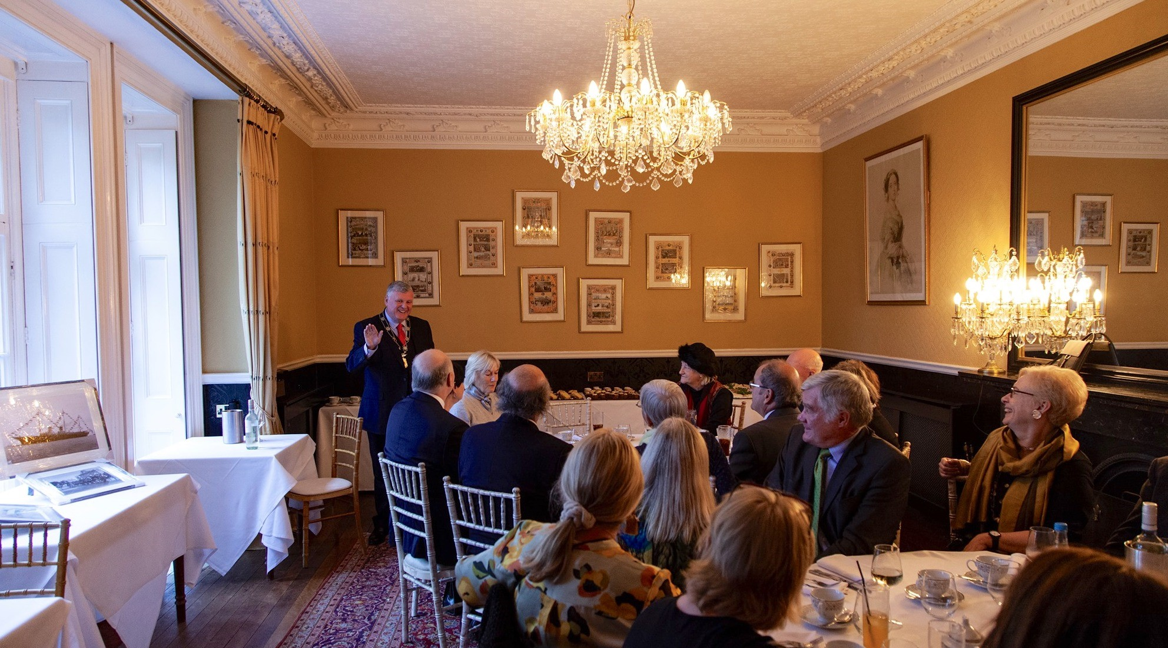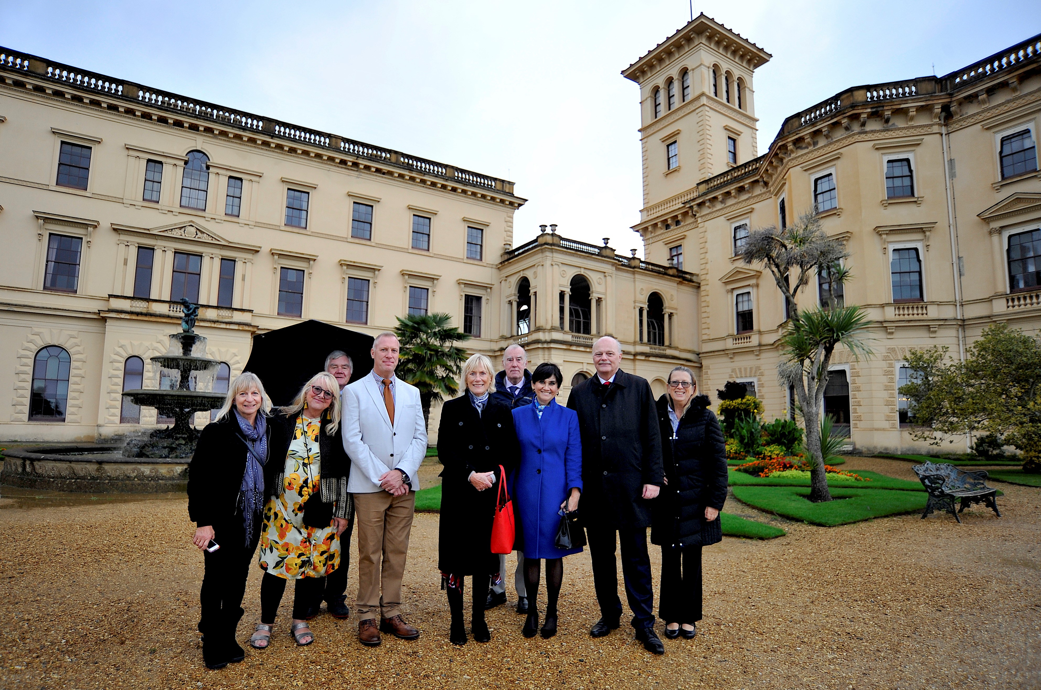
Crossways Public meeting held at CECAMM. Whippingham 16th October 2019
I was informed that this exaction of the Crossways Development was in response to the public consultation held at the East Cowes Town Hall. The team presenting the exaction had come down from Manchester and London. They informed me that the 106 money from Crossway development would be used by IWC to fund Copping Bridge road improvement. I asked how the money could be spent there instead of the the local area. They did not answer this question. Local members fro the East Cowes and Whippingham communities had many questions for the developers without much new information. The housing numbers had increased to 172 due to a number of houses being changed to1 bedroom flats.
East Cowes Community Partnership held at Heritage Centre. East Cowes 23 October 2019 Committee meeting discussed Remembrance Day Poppys for East Cowes and the location of displays. Christmas lights and Christmas Fair taking place on 7th December. VE Day 75th Anniversary Celebrations 2020. Planning for the event are ongoing to confirm bookings and groups taking part.
East Cowes Area Regeneration Group held at CECAMM. Whippingham 24th October 2019 This meeting was set up by the IWC Regeneration Team. The group exists to oversee actions taken to improvements the East Cowes Esplanade with ideas from the regeneration workshops held in 2018/19. Membership and chairing also took place. Meetings will take place every 6 weeks.
Reporting will be to East Cowes Town Council, Isle of Wight Council,
- East Cowes landslip research group. The project will research and collate information about the landslip and present recommendations for the short, medium and long term.
- Esplanade public realm group. The project will seek to make positive improvements to facilities and public realm of the esplanade area.
- Albany barracks art and cultural group.

